AUCKLAND  GIRLS  CHESS CHAMPIONSHIP  TERM 3 WEEK 4  THURSDAY  25 AUGUST, 2011  9 a.m. to 2.30 p.m.  MT ALBERT WAR MEMORIAL HALL  751-761 NEW NORTH Rd  MT ALBERT  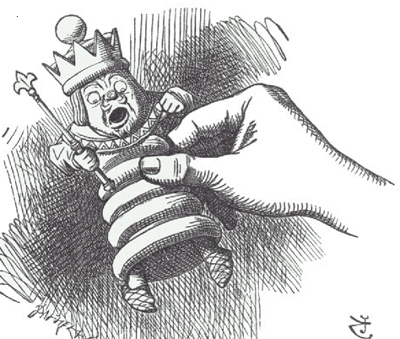  Organised by Waitakere Chess Club Inc.  Note: This is part of a nationwide Chess for Girls Week, an initiative of the New Zealand Chess Federation, to encourage girls to try chess in an all-girl environment.  Any queries please contact:  John Francis: 626 2213 or 027 2988539  Email: diaries@ihug.co.nz fax: 627 1412  or Viv or Bob Smith 021 1623342 or 0274 786 282  Or go to the New Zealand Chess website http://www.newzealandchess.co.nz/calendar.html for information and downloads. | FORMAT:  Three separate 6 round tournaments in age groups: Over 12, Under 12 and Under 10 years.  TIME CONTROL:  20 minutes plus 3 seconds per move  for each player per game.  TIMETABLE:  Players’ Meeting 9.00 a.m.  Round 1 9.10 a.m. - 9.50 a.m.  Round 2 10.00 a.m. - 10.40 a.m.  Round 3 10.50 a.m. - 11.30 a.m.  Round 4 11.40 a.m. - 12.20 p.m.  Lunch break  Round 5 12.45 p.m. - 1.25 p.m.  Round 6 1.35 p.m. - 2.15 p.m.  **Please arrive on time as the first round will start at  9.10 am sharp. Other round times are guidelines only,  and may be brought forward if rounds finish early**.  ENTRY FEE: $12.00 per person  ENTRIES CLOSE: Friday, 19 August 2011  No late entries accepted  CANTEEN  A canteen will be operating providing drinks and snacks, but students should bring their own lunches.  PRIZES:  Auckland age group titles will be awarded for:  pUnder 18  pUnder 16 Ages as at 1 January, 2011  pUnder 14  pUnder 12 At least 3 players required  pUnder 10 in each age group for title  pUnder 8  Winners will be acknowledged on the day. Trophies and medals for placegetters, plus participation certificates for all players will be posted to schools as soon as possible after the event.
- - - - - - - - - - - - - - - - - - - - - - - - - - - - - - - - - - - - - -  -- - - - - - - - - - - - - - - - - - - -  - - - - - - - - - - - - - - - - - - -

Entry Entry Form: Auckland Girls’ Chess Championship 2011

Name: …………………………………………………………. On 1 January 2011, I was …………… years old.
Address: ……………………………………………………… Date of Birth: ………………….. …Phone……………..…….
E-mail: ………………………………………………………… School: ……………….………… School ph: …...…………
◻ The entry fee of $12.00 is enclosed. Please make cheques payable to ‘Waitakere Chess Club’
Note:
1. Information collected on this form is for NZCF ‘Chess for Girls’ Weeks’ only.
2. Safety is the shared responsibility of the students and organiser. Accidents can happen even when the utmost
care is taken. Urgent medical care required is authorised.
3. Arrangements for the student’s care and transport must be made for after the event.

Signatures:
Teacher or Principal: …………………………… Date: ………… Parent: …………………………… Date: …………
Post entry form to: John Francis, Auckland Girls’ Chess Championship,

18 Hibiscus Place, Hillsborough, AUCKLAND

